ABOUT THE PROGRAMME:  The Postgraduate Certificate in Gender and Development Studies is launched from July, 2011.  The programme is likely to be of interest to academics and researchers; trainers, facilitators, supervisors; staff of organizations working in the area of gender and development; government personnel; personnel working in banks/ financial institutions.  PROGRAMME OBJECTIVES:  The programme seeks to enable learners to:  - Analyse extent of gender-sensitivity of development interventions;  - Conduct gender analysis and  - Critically analyze gender differentials in selected development sectors;  PROGRAMME STRUCTURE:  The broad structure for the PG Certificate in Gender and Development Studies is as follows:  ELIGIBILITY: Under graduation in any discipline.  CAREER OPPORTUNITIES:  Students completing this programme will be able to pursue their careers in the following areas:  - Can opt for higher studies and research programmes.  - Possibilities to work with Non-Profit Organizations both at National and International level.  - Careers in teaching and research.  - Can pursue careers in specialized areas like Corporate Social Responsibility, Gender Training Programmes, Special Column Writing, Editing, and Mass Media.  PROGRAMME FEE:  Postgraduate Certificate (Distance Mode):  Rs. 1500/-  (excluding all other University fees.)  Relevance of the programme:  The certificate programme would be useful for functionaries employed in Governmental and Non-Governmental sector who are engaged in activities and interventions to promote gender equality and women’s empowerment.  The programme would also be of interest to persons seeking to gain awareness of gender sensitivity in developmental activities and interventions.  Field level functionaries engaged in gender analysis would gain knowledge and skills that they would find useful in practice. |  | Modular Approach to Programmes in Gender and Development Studies  As part of the modular approach to programmes in Gender and Development Studies the following programmes are on offer:  - Postgraduate Certificate in Gender and Development Studies (16 credits)  - Postgraduate Diploma in Gender and Development Studies (36 credits)  - M.A. in Gender and Development Studies (72 credits)  Learners enrolled for the P.G. Diploma can exit after successful completion of MGS-001, MGS-002 and MGS-003 with a Postgraduate Certificate in Gender and Development Studies.  Leraners enrolled for the M.A. in Gender and Development Studies can exit after successful completion of the first year courses with a Postgraduate Diploma in Gender and Development Studies.  The first year courses are as follows:  PROGRAMME COORDINATORS (Distance mode)  Prof.Annu J Thomas  School of Gender and Development Studies  Indira Gandhi National Open University  Maidan Garhi  New Delhi – 110 068  E-mail: athomas@ignou.ac.in  Ph.No:011-29572961(O), 9811960972 (M)  Prof.Savita Singh  Director  School of Gender and Development Studies  Indira Gandhi National Open University  Maidan GArhi  New Delhi – 110 068  E-mail: savitasingh@ignou.ac.in  Ph.No: 011-29573095 (O), 9711401974 (M)  FOR FURTHER INFORMATION PLEASE CONTACT  Prof. Savita Singh  Director  School of Gender and Development Studies  Indira Gandhi National Open University  Maidan Garhi  New Delhi – 110 068  E-mail: sogds@ignou.ac.in  E-mail: savitasingh@ignou.ac.in  Ph.No: 011-29573095 (O), 9711401974 (M)  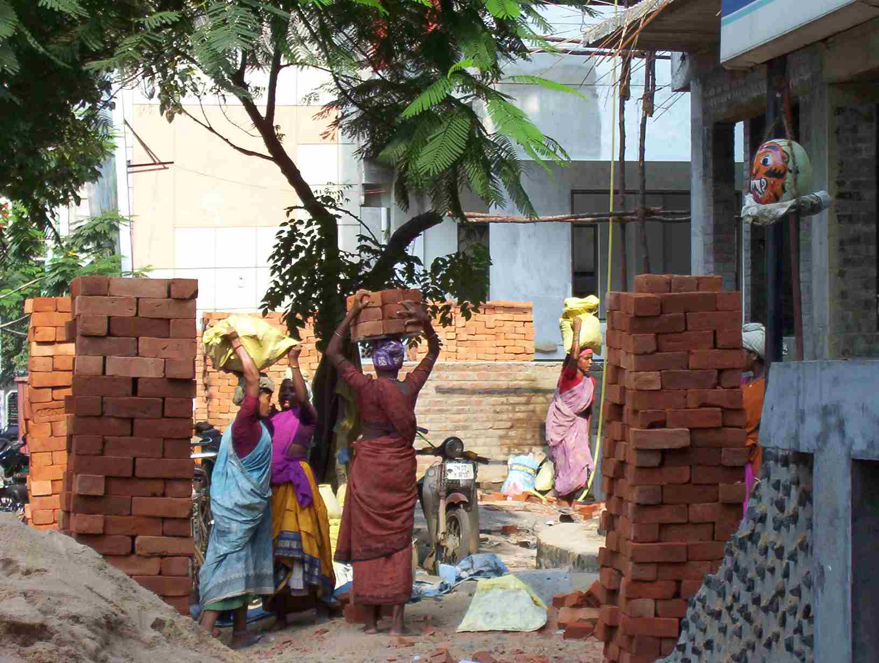 |  | Credit Transfer would be provided to learners who have completed courses of the postgraduate certificate/postgraduate diploma and then enrolled for the M.A. Programme.  Duration of the Programmes:  If the learner is unable to complete the programme in the maximum duration mentioned, he/she would have to seek re-admission with payment of the stipulated fees. The programmes can not be completed before the minimum duration mentioned.  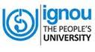  Postgraduate Certificate in Gender and Development Studies  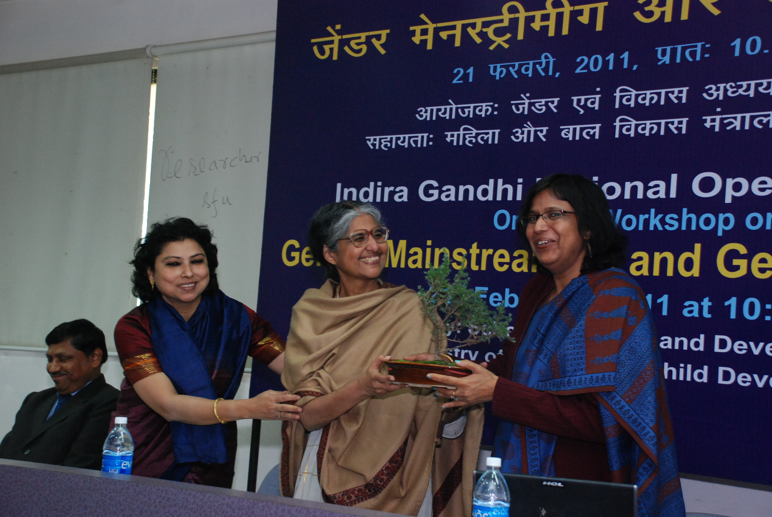  School of Gender and Development Studies  Indira Gandhi National Open University  New Delhi  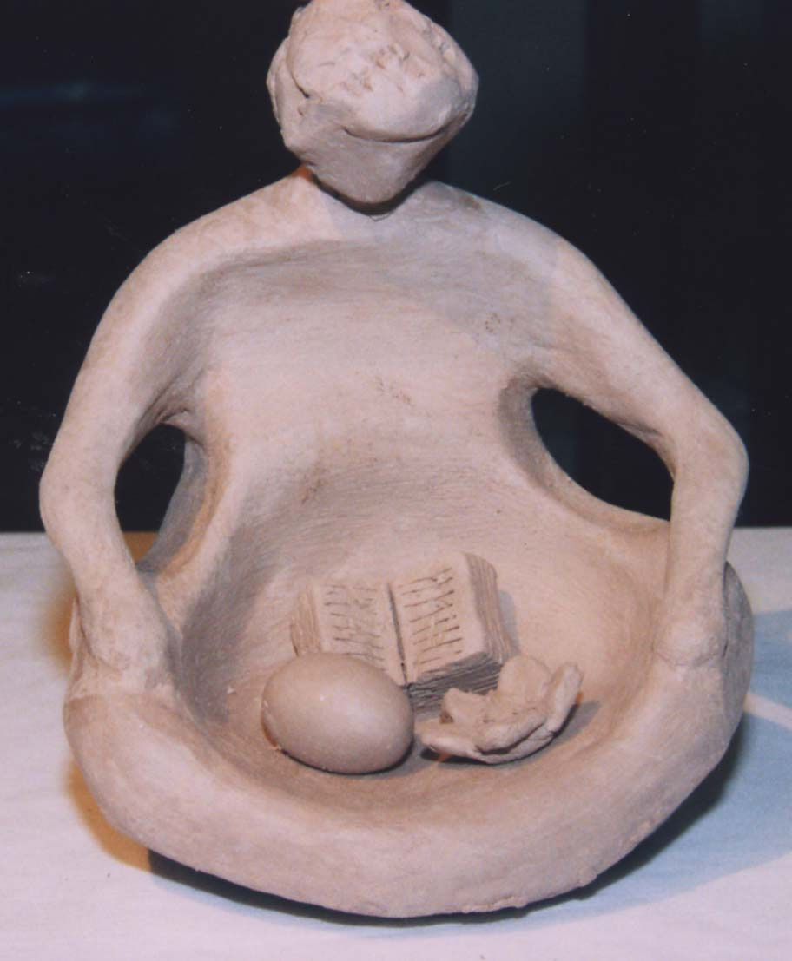
  S.No. | Course Code | Course Title | Cre-dits*
  1. | MGS-001 | Gender and Development: Concept, Approaches and Strategies | 6
  2. | MGS-002 | Gender, Development Goals and Praxis | 6
  3. | MGS-003 | Gender Analysis | 4
  S.No. | Course Code | Course Title | Credits*
  1. | MGS-001 | Gender and Development: Concept, Approaches and Strategies | 6
  2. | MGS-002 | Gender, Development Goals and Praxis | 6
  3. | MGS-003 | Gender Analysis | 4
  4. | MGS-004 | Gender-sensitive Planning and Policy Making | 8
  5. | MGS-005 | Research Methodologies in Gender and Development Studies | 8
  6. |  | Internship/Field-based Research Project | 4
  Programme | Min. Duration | Max. Duration
  Postgraduate Certificate in Gender and Development Studies | Six months | Two years
  Postgraduate Diploma in Gender and Development Studies | One year | Four years
  M.A. in Gender and Development Studies | Two years | Five years

